DR. AMBEDKAR COLLEGE, DEEKSHA BHOOMI, NAGPUR
ANTI RAGGING CELL

Date: 15th December 2022
Name of the Programme: Lecture on “Anti- Ragging in College”
Resource Persons: Shri Ajay Govind
Organised by: Department of Law (Induction Program) And Anti-Ragging Cell
Name of Program Co-ordinators: 1. Dr. Sandhya Kalamdhad
2. Ms. Shilpa Rathod
Number of Attendees: Around 184
Mode: Offline and Online through Google meet
Name of Venue: Seminar Hall, Department of Law

NOTICE

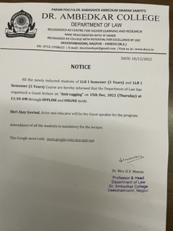

REPORT ON AWARNESS PROGRAM

The Department of Law and Anti Ragging Cell of Dr. Ambedkar College, Deeksha bhoomi Nagpur, has organised a Guest Lecture on 15th Dec 2022 for the newly inducted Students of LLB 3 year and LLB 5 Year courses.
Around 184 attendees were present in the program through Offline and Online Mode. Shri Ajay Govid, Film maker and Educator from Delhi invited as guest speaker in the program.

Dr. Hema Menon, Professor and Head Department of Law gave brief information regarding the topic of the lecture along with the welcome address.

Shri Ajay Govind enlightened the audience on the topic of Anti-ragging. He mentioned that doing the ragging and act of helping to do ragging both are wrong. It is individual responsibility to response this act. He empathetically mentioned that there is a psychological element involved in the cases of ragging and explained in dept that the willingness of the person on whom the ragging is done is of utmost importance. If the senior asked Junior to do some time which is not wrong and the same has been willing done by the junior happily with all intension and enthusiasm then there is no unlawful act. But if Juniors are asked to do anything against their wishes, then it is not justified.

The lecture is followed by the question-and-answer session wherein the different students asked the variety of questions which has been nicely answered by the guest speaker with full satisfaction of the students.

The hon’ble guests overwhelmed by knowing that our college has no case of Ragging till the present date and for that they have congratulate the college.

The Programme was conducted and concluded with vote of thanks proposed by Ms. Shilpa Rathod under the guidance & supervision of Dr. Sandhya Kalamdhad, Professor and Co-ordinator of Anti ragging Cell of the college.
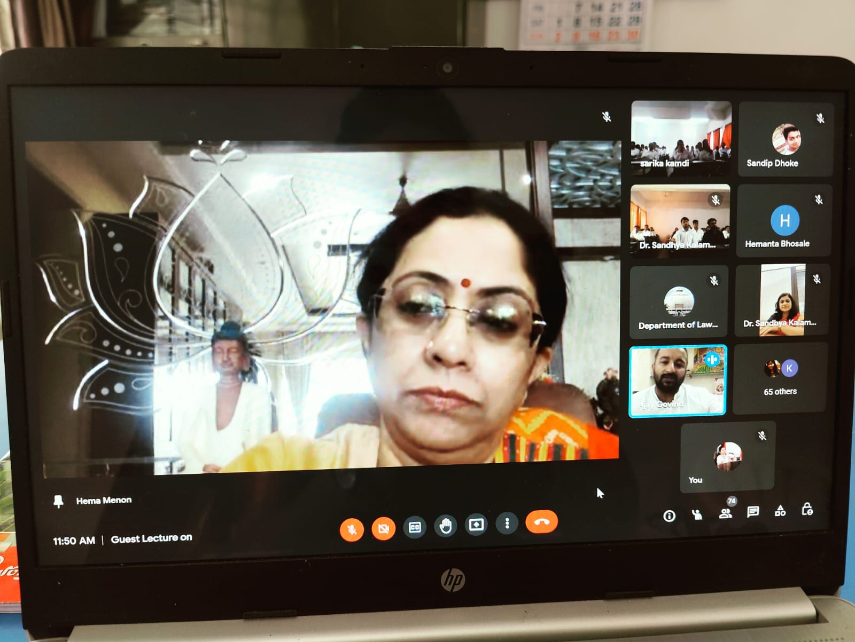
(Dr. Hema Menon, Professor and Head of the Department giving the welcome address)

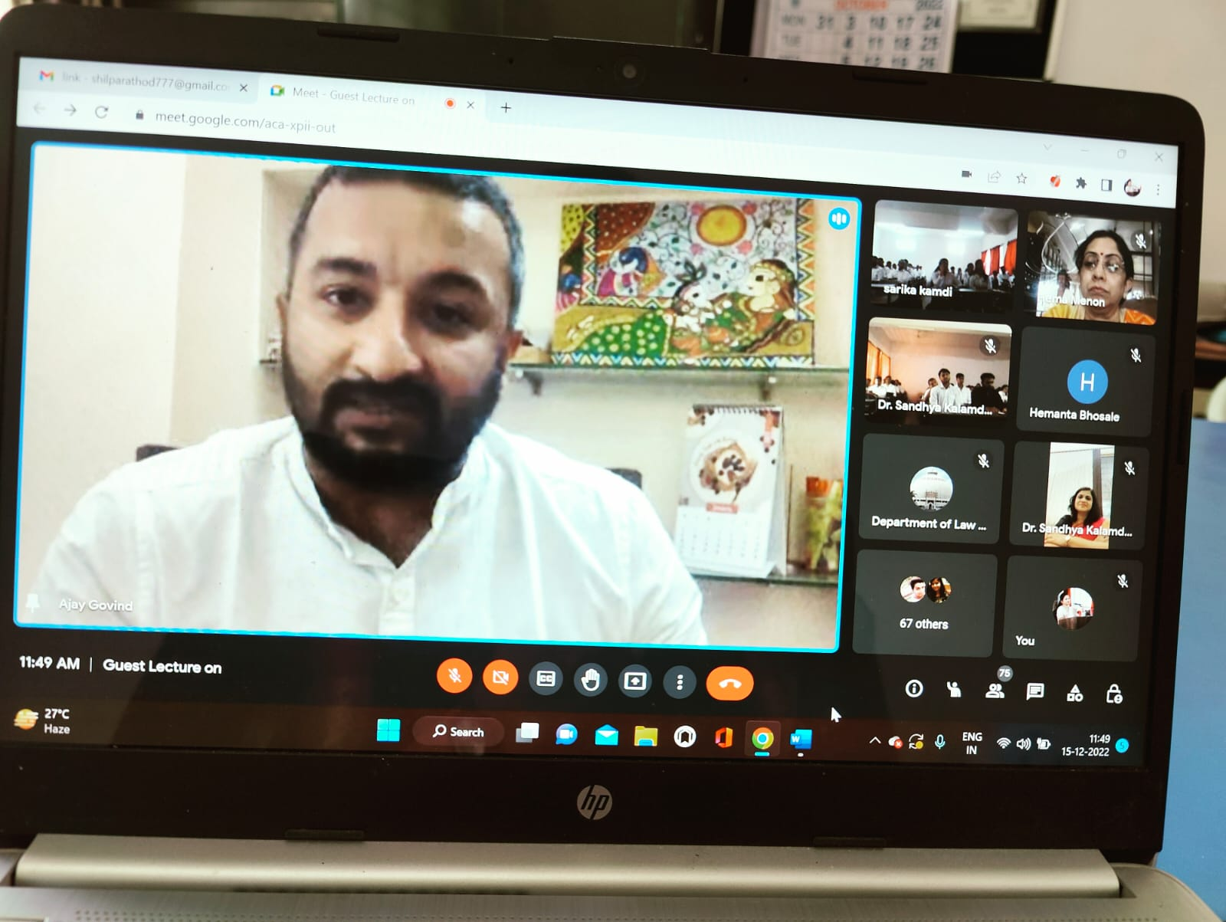
(Hon’ble Shri Ajay Govind delivering the lecture)
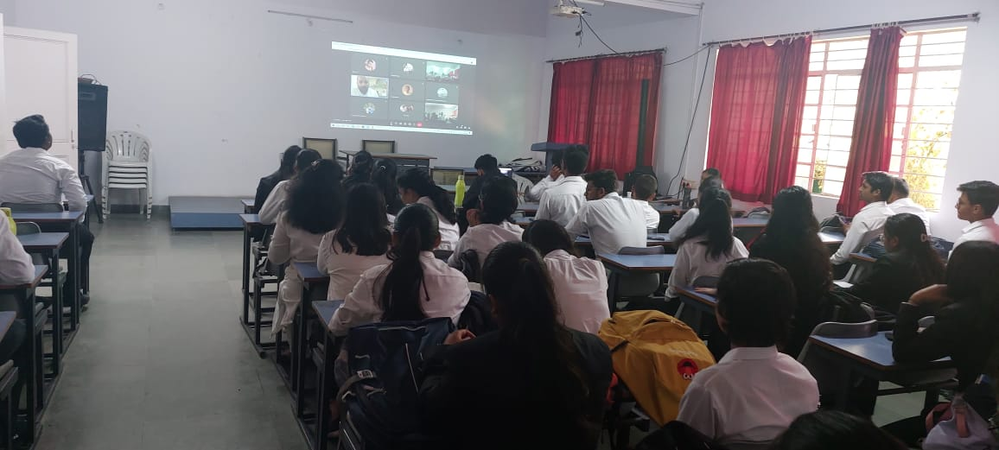
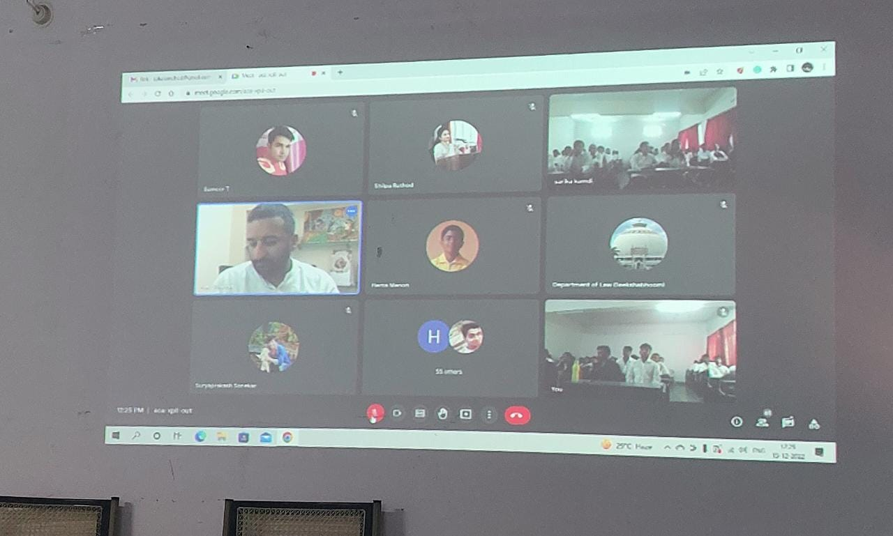
(Audience Present at the Awareness Programme through Online and Offline mode)

